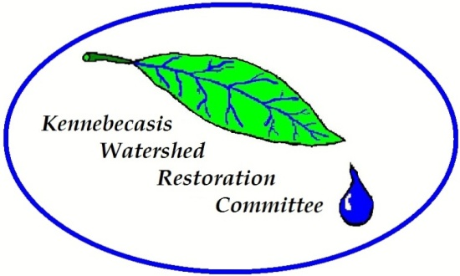
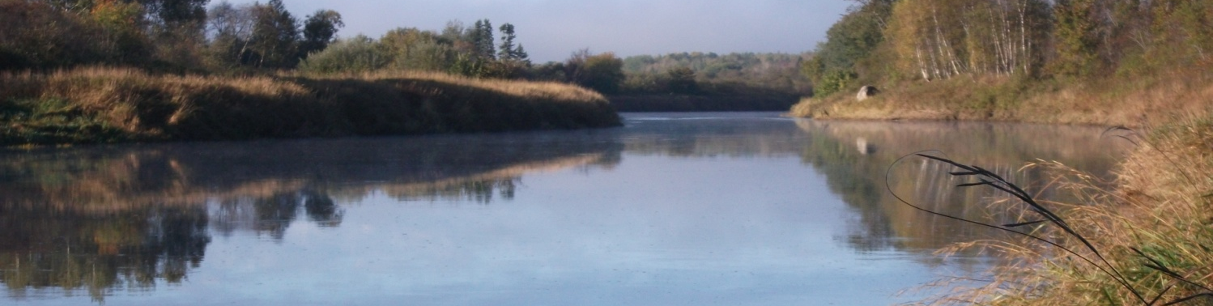
5 Moffett Avenue, Unit E, Sussex, NB, E4E 1E9 info@kennebecasisriver.org (506)433-4394

JOB POSTING

Habitat Restoration Coordinator

_____________________________________________________________________________________

LOCATION: Sussex, NB
TERMS: Full time based on funding availability

ANTICIPATED START DATE:
As soon as possible

SALARY: $22-24/hr

EDUCATION: Graduation with a degree/diploma in the natural sciences from a recognized university or community college or courses from a recognized university or community college in a related science combined with acceptable experience.
JOB SKILLS: Ability to communicate effectively in writing and orally; proficiency in the use of computer applications such as word processing and spread sheet software; ability to work within a partnership; ability to work in a team. Mapping and GIS would be considered an asset. The applicant must be comfortable working in and around water, in all types of weather conditions, and in remote locations. Should be physically fit and be comfortable walking and navigating through remote locations and in the wilderness. Possess an aptitude for tree and fish identification or the use of on-line apps. Knowledge or experience working within a non-profit organization would be considered an asset.
JOB DESCRIPTION: Supervision of restoration crews on a day to day basis. Assist in the development and implementation of numerous watershed restoration projects. Layout restoration sites and schedule workdays for tree planting, fencing, and other watershed restoration activities. Maintain effective liaisons with government officials, stakeholders, landowners, and funding agencies.
Assist with the completion of watershed monitoring and assessment projects as directed by Project Manager. This position may also require some accounting skills in order to monitor project budgets.

CONDITIONS OF EMPLOYMENT: Willingness and an ability to work in an outdoor field environment. Possess a Valid Driver’s License. Forty hours/week and dependant upon funding.

EMPLOYER: Kennebecasis Watershed Restoration Committee
5 Moffett Ave, Unit E
Sussex, NB E4E 1E9
ben.whalen@kennebecasisriver.org (506)433-4394

