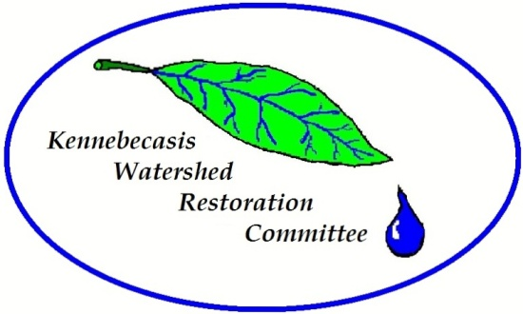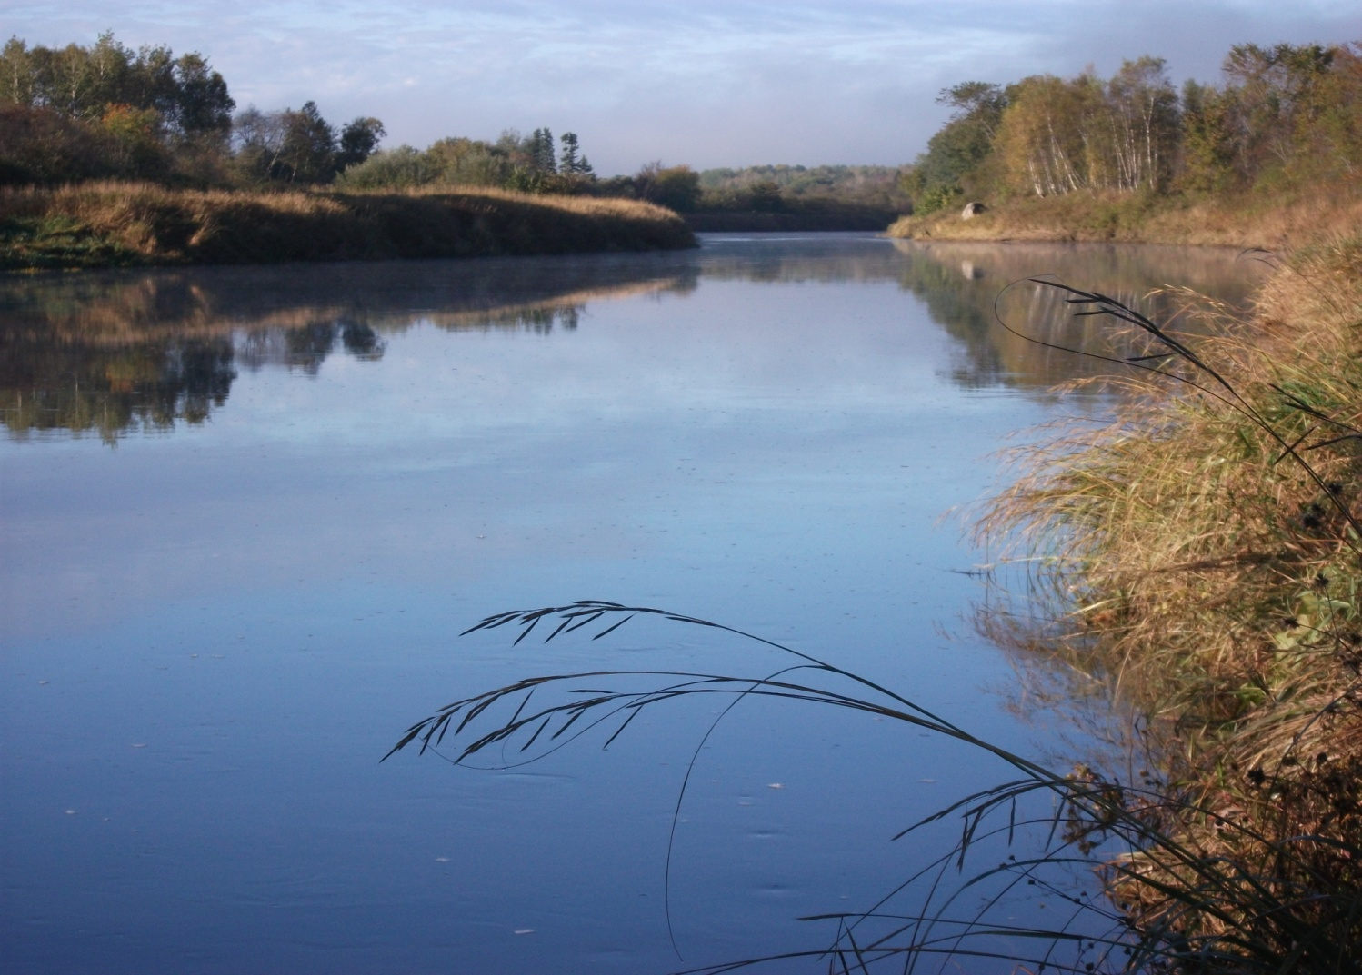

5 Moffett Avenue, Unit E, Sussex, NB, E4E 1E9 [info@kennebecasisriver.org](mailto:info@kennebecasisriver.org) (506)433-4394

**JOB POSTING**

**Biodiversity Coordinator** _____________________________________________________________________________________

**LOCATION:** Sussex, NB

**TERMS:** Full time based on funding availability

**ANTICIPATED START DATE:** June 2025

**SALARY:** $18.00-$21.00/hr

**EDUCATION:** Graduation with a diploma/degree in the natural sciences from a recognized university or community college or courses from a recognized university or community college in a related science combined with acceptable experience.

**JOB SKILLS:** Ability to communicate effectively in writing and orally; proficiency in the use of computer applications such as word processing and spread sheet software; ability to work within a partnership; ability to work in a team. Mapping and GIS would be considered an asset. The applicant must be comfortable working in and around water, in all types of weather conditions, and in remote locations. Should be physically fit and be comfortable walking and navigating through remote locations and in the wilderness. Possess an aptitude for tree, bird and fish identification or the use of on-line apps. Knowledge of species at risk, in particular swallows and their habitats would be beneficial. Knowledge or experience working within a non-profit organization would be considered an asset.

**JOB DESCRIPTION:** The Biodiversity Coordinator will focus on helping the KWRC team manage species at risk and invasive species while increasing biodiversity within the Kennebecasis watershed. You will work to create action plans for invasive species such as Curly Leaf Pondweed, Japanese Knotweed, Eurasian Watermilfoil, Zebra Mussels, etc. You will be familiar with species at risk in New Brunswick, such as bank swallows and monarch butterflies, and will understand how they become endangered and share ideas on how populations can be restored. You will track existing levels of biodiversity around our restoration sites. You will use various tools such as Merlin and iNaturalist to aid in your work. You will monitor for Emerald Ash Borer, set collector plates to monitor for zebra mussels, and look for curly-leafed pondweed. You may be asked to assist with restoration and/or monitoring work to understand your connection to the rest of the team. You will write proposals and reports to assist in growing our organization.

**CONDITIONS OF EMPLOYMENT:** Willingness and an ability to work in an outdoor field environment. Possess a Valid Driver’s License. Forty hours/week and dependant upon funding.

**EMPLOYER:** Kennebecasis Watershed Restoration Committee

5 Moffett Ave, Unit E

Sussex, NB E4E 1E9

[ben.whalen@kennebecasisriver.org](mailto:info@kennebecasisriver.org) (506)433-4394

**CLOSES:** April 25, 2025